Project Design Phase

Solution Architecture

|  |  |
| --- | --- |
| Date | 15 june 2025 |
| Team ID | LTVIP2025TMID31490 |
| Project Name | HealthAI: intelligent healthcare assistant |
| Maximum Marks | 4 Marks |

Solution Architecture:

This architecture outlines how the various components of the healthcare assistant interact to deliver fast, safe, and intelligent AI responses based on user symptoms.

* Collects Natural Language Input:

 Accepts symptom descriptions in plain language via a web or app interface.

* Processes and Formats Input Prompt:

 Backend formats the symptom input into a structured prompt for IBM Granite.

* AI Model Integration (IBM Granite):

 Uses IBM Granite 3.3-2B Instruct model to infer likely medical conditions based on symptoms.

* Real-Time Response Generation:

 Returns AI-generated results in under a few seconds for live user interaction.

* Displays Results with Safety Disclaimers:

 Outputs are shown with timestamp and warning that it’s not a diagnosis.

* Cloud & API Friendly Architecture:

 Easily deployable via Hugging Face, IBM Cloud, or custom API infrastructure.

* Secure & Compliant:

 Can be made HIPAA/GDPR compliant by avoiding data storage and using secure APIs.

* Scalable & Modular:

 Architecture allows adding voice input, multilingual support, or integrations with EMR or telehealth platforms.

Example - Solution Architecture Diagram:

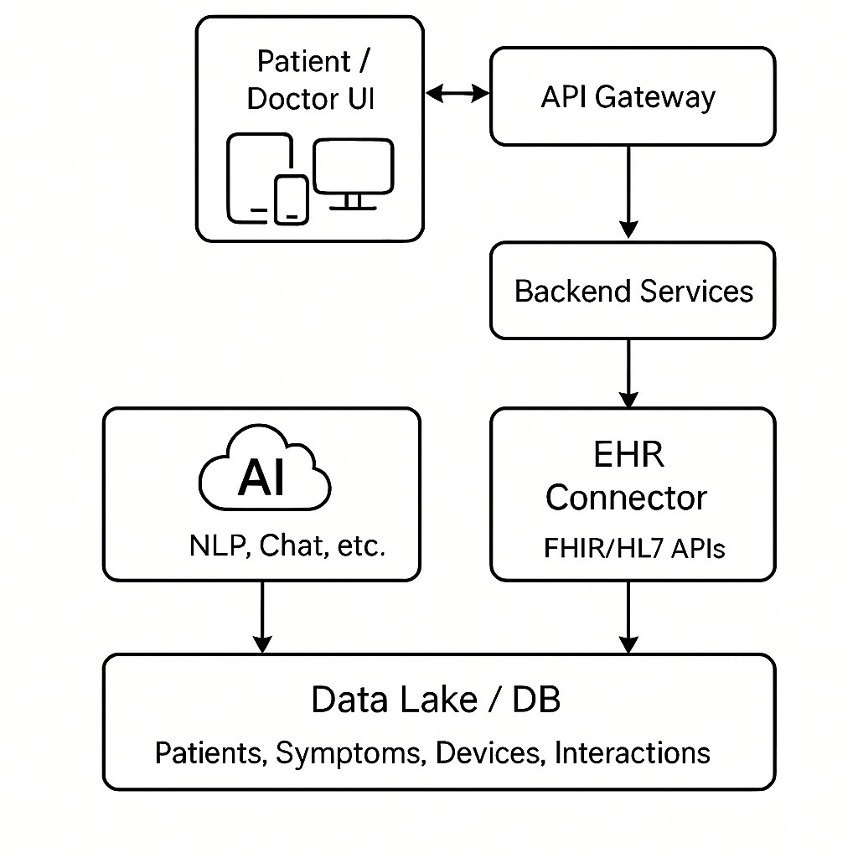

*Figure 1: Architecture and data flow of the voice patient diary sample application* Reference: https://www.microsoft.com/en-us/industry/health /microsoft-cloud-healthcare https://cloud.google.com/customers/mayo-clinic